**CIS3100**

**KARY HUANG**

**ASSIGNMENT #5**

**05/09/2016**

**INPUT**

//Kary Huang Assignment #5

#include <iostream>

#include <cmath>

#include <fstream>

#include <iomanip>

#include <string>

using namespace std;

float final_grade(float[], int[]); //prototype for the student average function

int main()

{

ifstream a5in("C:\\Users\\kary\\Desktop\\CIS3100\\KaryHuangAssignment5\\a5in.txt");

ofstream a5out("a5out.txt");

string student_first, student_last, max_first, max_last, min_first, min_last;

float weights[4]; //the array for weights

int grade[8]; //the array for grades

int i, j, x, student_id;

float min = 100.0, max = 0.0, student_avg, sum = 0.0;

a5out << "First Name" << setw(3) << " " << "Last Name" << setw(3) << " " << "Student ID" << setw(3) << " " << "Final Grade" << endl; //column headings

for (i = 0; i < 4; i++) //read in weights into first array

{

a5in >> weights[i];

}

for (x = 1; x <= 15; x++) //read in 15 sets of student record

{

while (a5in >> student_first) //if there is a student first name, then perform the following

{

a5in >> student_last;

a5in >> student_id;

a5out << left << setw(13) << student_first << setw(12) << student_last << setw(13) << student_id;

for (j = 0; j < 4; j++) //read in grades into second array one student at a time

{

a5in >> grade[j];

}

student_avg = final_grade(weights, grade); //call the student average function

a5out << student_avg << endl;

sum = sum + student_avg;

if (student_avg > max)

{

max = student_avg;

max_first = student_first;

max_last = student_last;

}

if (student_avg < min)

{

min = student_avg;

min_first = student_first;

min_last = student_last;

}

}

}

a5out << "\nLowest grade in class: " << min_first << " " << min_last << " " << min << endl;

a5out << "Highest grade in class: " << max_first << " " << max_last << " " << max << endl;

a5out << "Class average: " << fixed << setprecision(2) << sum / 15.0 << endl;

a5in.close();

a5out.close();

return 0;

}

float final_grade(float weights[], int grade[]) //the student average function

{

int k = 0;

return (weights[0] * grade[k] + weights[1] * grade[k + 1] + weights[2] * grade[k + 2] + weights[3] * grade[k + 3]);

}

**OUTPUT**

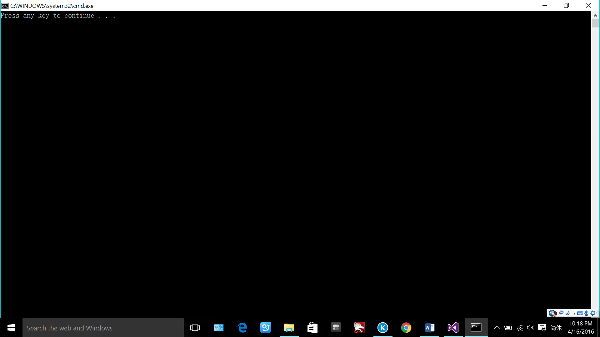

**a5in.txt**

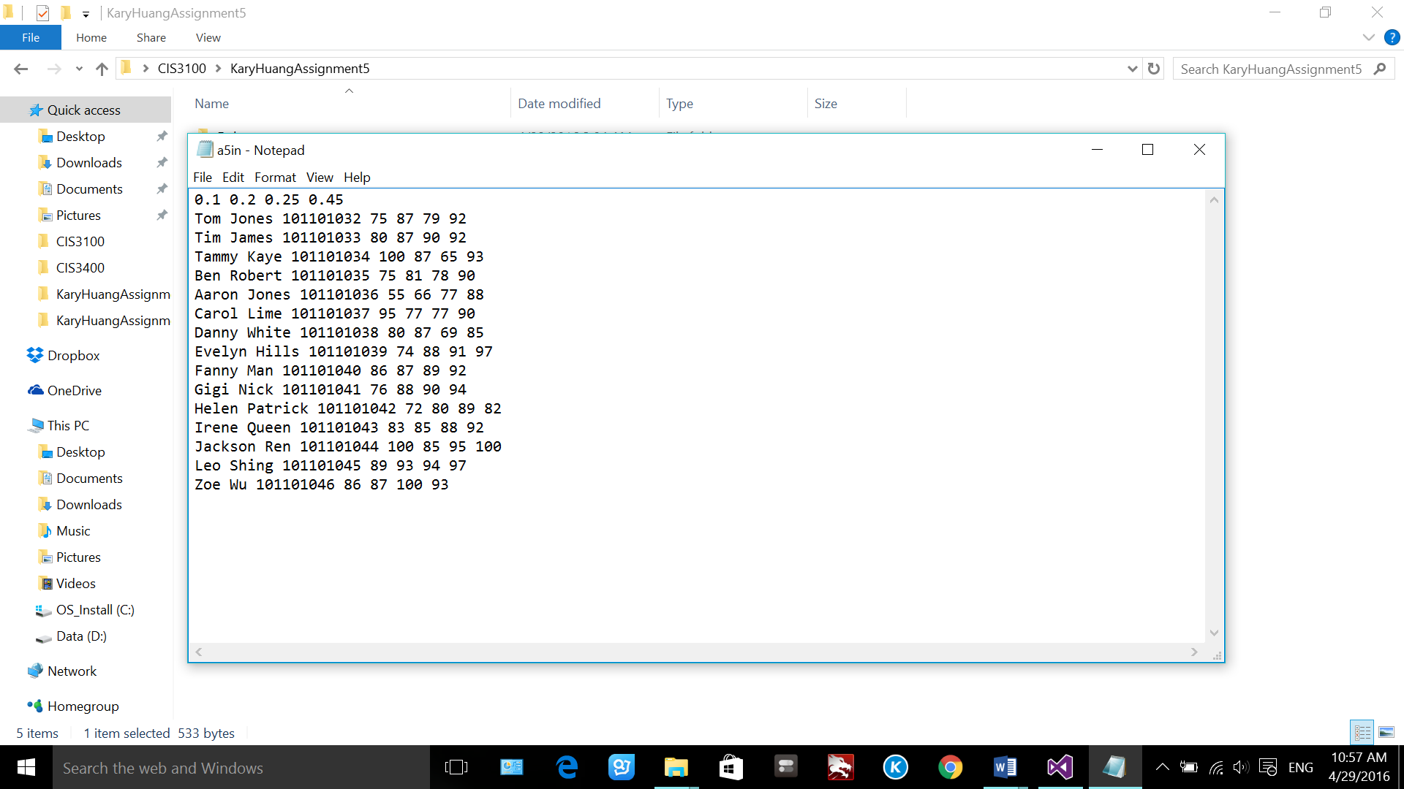

**a5out.txt**

